Section 4
Section4.1(Definations 1-3 are in my prev summary)

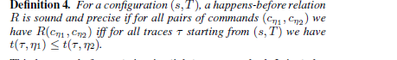
For read,write and arrive,time t(T, .) is taken to execute. Corresponding barrier is recycled for sync instruction to execute. Happens-before relationship is established using time but this relation is nonn-standard because all sync commands that synchronize together are included.

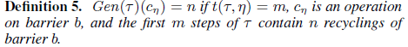
As disscussed before, generations are defined for well synchronization. Gen(T) maps to generationID in trace T. For example, a generation ID of 2 for a command sync 0 n indicates that this command was used to register on barrier 0 after this barrier has been recycled once previously. The generation ID of unexecuted commands is set to 0.

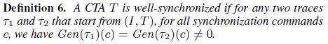
CTAs with the same generation mapping for all traces are called well-synchronized.

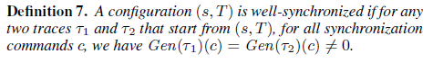
If any 2 traces start from any configaration (s,T) and Gen(1)(c) = Gen(2)(c) not equal 0, it is said to be well synchronization. We are checking for a non-zero for no deadlock or error to occur. This ensures safe barrier recycling, deadlock frredom and synchronization behaviour to be deterministic.

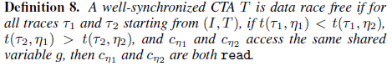
Data races are intoduced if 2 commands access the same shared variable which don't have happens-before relationship between them. If that 2 commands are read, then it will be race freedom.

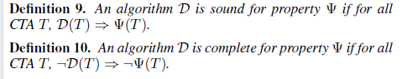
These are the definations for soundress and completeness respectively.

Section 4.2
A example is taken where thread P and Q have thread ID 0 and 32 respectively and lane_id is thread_ID%32 so both P and Q will have same lane_id. This will cause data race in threads P and Q. Each location g[j] in shared memory is assigned as a separate variable. Here, j euals lane_id.

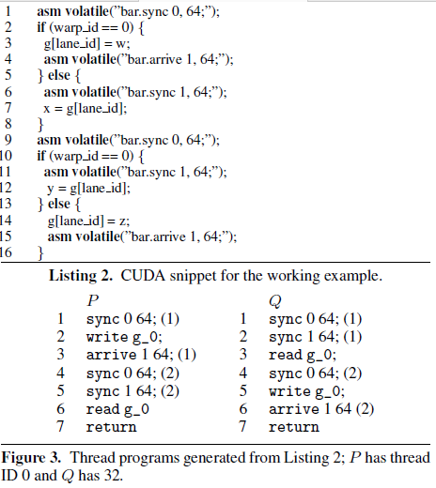
At first, Gen(T) assigns a non-zero value to all synchronization commands. The first command
of all threads synchronize on barrier 0 creating the first generation of barrier 0. Then the fourth command of all threads synchronize again on barrier 0 and this time the assigned generation ID is 2. For Figure 3, we need to check that there are
happens-before relationships between the write in P and the write in Q, between the write in P and the read in Q and vice versa. P and Q programs are race- free as in fig 5 we observe that there is a path between any two accesses
to the shared memory.

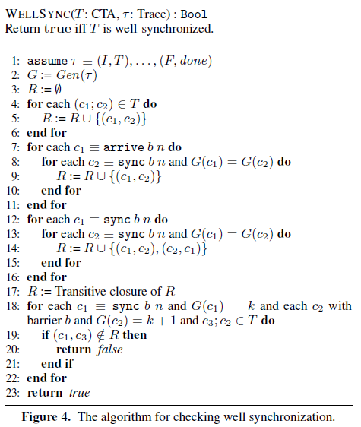
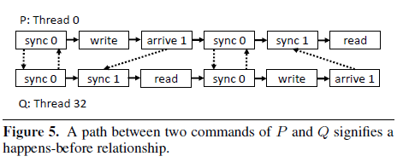
We use Gen(T ) to construct a static happens-before relation. The graph starts with no edges and lines 4-6 add the solid edges, corresponding to instruction ordering relations within individual threads.
Then adges are added to the inter-thread happens-before relations. If c1 is an arrive and c2 is a sync such that the two commands are in the same generation, then add (c1; c2) to R. Now, for c1 and c2 corresponding to sync in the same generation, add (c1; c2) and (c2; c1) to R. Lines 7 to 16 perform these steps and result in the dashed edges in Figure 5. There are cycles in this figure because the happens-before relation includes the commands that execute simultaneously (e.g. sync on the same barrier). Finally, we compute the transitive closure of R (line 17) thus yielding the full static happens-before relation. There is a path between c1 and c2 in Figure 5 iff (c1; c2) belongs to R.
Lines 18 to 23 check that there exists happens-before relationships between successive generations of the same barrier. On line 19, we check for (c1; c3) instead of (c1; c2) because we need to check that the program point just before c2 happens after c1.
With this algorithm we have shown that successive generations are separated by a happens-before relationship and therefore the CTA is well synchronized.

The well synchronization property imposes barrier generations in all traces and there is no out of order execution of commands withn individual thread programs, all the tuples whichh are added to R are sound and direct. The tuples in R are the only restrictions on the ordering in the executions imposed by the semantics. We are using R to ensure that generations
are ordered.

In the induction step, we have a well-synchronized configuration (s1, T1) and suppose in the given trace (s2, T2) → (s1, T1). Then the checks in WELLSYNC ensure that the new generation introduced in going from T1 to T2 has a happens-before relationship with generations in T1 and (s2, T2) is well-synchronized.
The time complexity of WELLSYNC is dominated by the cost of computing the transitive closure, which for a CTA with n commands can be O(n^3) in the worst case.

If we succeed in proving that T is well-synchronized, then we have proven that all executions of T are deadlock free and recycle named barriers safely.

For two commands c1 and c2 that are accessing the same shared memory location with at least one write, we report a race if (c1, c2) does not belong to R and (c2, c1) doesn't belong to R.

